Candidate Number

Please stick the barcode label here.

Marker’s

Use Only
 |  | Marker No.
Question No. |  | Marks
1
2
3
4
5
6
7
8
9
10
11
12
13
Total

ARISTO EDUCATIONAL PRESS

HONG KONG DIPLOMA OF SECONDARY EDUCATION EXAMINATION

ECONOMICS PAPER 2
(Mock Test 34)

Question-Answer Book

Time allowed: 2 hours 30 minutes
This paper must be answered in English

INSTRUCTIONS
- After the announcement of the start of the examination, you should first write your Candidate Number in the space provided on Page 1 and stick barcode labels in the spaces provided on Pages 1, 3, 5, 7, 9, 11, 13, 15, 17, 19, 21, 23 and 25.
- This paper consists of three sections, A, B and C. Answer ALL questions in sections A and B. Attempt any ONE question in section C.
- Write your answers in the space provided in this Question-Answer Book. Do not write in the margins. Answers written in the margins will not be marked.
- Supplementary answer sheets will be supplied on request. Write your candidate number, mark the question number box and stick a barcode label on each sheet, and fasten them with string INSIDE this book.
- No extra time will be given to candidates for sticking on the barcode labels or filling in the question number boxes after the ‘Time is up’ announcement.

Section A (44 marks)

1. Mr. Chan is a renovation worker. Recently, he has borrowed $30,000 from his friend, Miss Wong, to purchase renovation tools. Mr. Chan has promised to return the money to Miss Wong one month later and would also install a new light for her home.

(a) Explain why the light and the installation service provided by Mr. Chan could be regarded as ‘interest’ to Mr. Chan. (2 marks)

(b) Suppose Miss Wong does not like the light. Explain whether Mr. Chan’s opportunity cost of installing a new light for Miss Wong’s home will change. (2 marks)

2. Refer to the following information about two firms. The two firms produce the same good.

 | Firm A | Firm B
Quantity of output per day (units) | 900 | 975
Number of workers | 15 | 10
Number of working hours per worker per day | 6 | 6.5
Percentage of output with quality up to standard | 95% | 80%

(a) Explain which firm has a higher average labour productivity. (3 marks)

(b) Based on the above information, compared with firm B, explain why firm A is more likely to pay its workers at time rate. (2 marks)

(c) Apart from the reason about the wage payment method, suggest TWO possible reasons for the difference in average labour productivity between the two firms. (2 marks)

Please stick the barcode label here.

3. Mr. Chan rents a store in a shopping mall to run a tutorial centre in the form of a sole proprietorship, specialising in teaching economics. He prepares economics teaching materials and videos for his students to revise at home.

(a) Later, Mr. Chan invited Miss Li, an English teacher, to form a partnership to expand his business. Suggest TWO reasons why Mr. Chan switched his firm’s form of business ownership for expansion.
(2 marks)

(b) After the tutorial centre opened more branches, the tutorial centre found that its average cost decreased. Give TWO reasons to explain why there is such a change in the average cost. (4 marks)

4. The British Government announced that from April 2024, the minimum wage level for employees aged 21 and above will be raised from the current £10.42 per hour to £11.44 per hour.

(a) ‘Raising the minimum wage level will reduce the competitiveness of companies in Britain.’ Explain whether this is a positive statement. (2 marks)

(b) Suppose cleaners in Britain receive the minimum wage. ‘Raising the effective minimum wage level will not necessarily increase the total wage earnings of cleaners in Britain.’ With the aid of a diagram, justify this statement. (7 marks)

Please stick the barcode label here.
5. Refer to the following data of an economy.

Year | Consumer Price Index (CPI)
2021 | 108
2022 | 102

(a) Calculate the inflation rate in 2022. (1 mark)

(b) Explain ONE difference between using the CPI and Gross Domestic Product (GDP) deflator to measure the change in the price level. (2 marks)

(c) ‘The above change in the consumer price index will occur if the money supply is growing slower than the amount of goods and services produced.’ Explain this statement with reference to the quantity theory of money. (4 marks)

6. The following table shows the amount of resources required by Country A and Country B for the production of computers and watches.

 | 1 unit of computers | 1 unit of watches
Country A | 12 units | 20 units
Country B | 5 units | 15 units

(a) Which good would Country A export according to its comparative advantage? Explain. (3 marks)

(b) Suppose the two countries trade at an exchange ratio of 5 units of computers to 2 units of watches. The watch-exporting country has to pay a transportation cost of 0.2 units of computers for each unit of watches traded. Calculate the gain per unit of export for Country A. Show your workings. (3 marks)

Please stick the barcode label here.
7. Refer to the following information of an economy in a certain year.

 | $ million
Current account
Visible trade balance | 100
Invisible trade balance | ‒20
Net factor income from abroad | 55
Net current transfers | ‒50
Capital and financial account
Balance of capital and financial account (excluding changes in reserve assets) | ‒120

(a) Explain whether the current account is in deficit or surplus. (2 marks)

(b) Explain whether the balance of payments is in surplus or deficit. Calculate the change in reserve assets.
(3 marks)

END OF SECTION A

Section B (60 marks)

8. To reduce air pollution caused by diesel private cars, the government of a country encourages people to commute by bicycles instead of diesel private cars. Some government officials have made the following two suggestions:

Suggestion 1: to provide a subsidy to rental bicycle operators, with a fixed subsidy per rented bicycle
Suggestion 2: to provide a subsidy to bicycle users, offering a fixed subsidy for each bicycle rental

(a) Explain, in terms of externalities, how the use of diesel private cars may lead to inefficiency. (3 marks)

(b) With the aid of a diagram, explain how suggestion 1 will affect consumer surplus in the rental bicycle market. (7 marks)

(c) Discuss how suggestion 2 will affect the average rental time for people using bicycles. (4 marks)

Please stick the barcode label here.

9. The table below shows the balance sheet of the banking system of Country A.

Assets ($ million) |  | Liabilities ($ million)
Reserves  Loans | 3,000  5,000 | Deposits | 8,000

Initially the banks hold $1,000 million excess reserves and the public always hold $500 million cash. Suppose the central bank purchases $20 million worth of government bonds from the public.

(a) Give ONE possible reason for the banks to hold excess reserves. (1 mark)

(b) Calculate the maximum possible change in money supply. Show your workings. (4 marks)

(c) Suppose there exists an inflationary (output) gap in Country A.

(i) Define inflationary (output) gap. (1 mark)

(ii) With the aid of an AS-AD diagram, explain how the above monetary policy would affect the inflationary (output) gap. (7 marks)

Please stick the barcode label here.

0
Quantity
Unit price (in terms of HKD)
Figure 1

Please stick the barcode label here.
10. The table below shows the change in the exchange rate of the British pound (GBP) to the US dollar (USD) between October 2022 and July 2023.

(Source: Federal Reserve Bank of St. Louis)

(a) Explain whether the Hong Kong dollar (HKD) appreciated or depreciated against GBP during the above period. (2 marks)

(b) How would the above change in the exchange rate affect the cost of living in terms of Hong Kong dollars for Hong Kong students studying in Britain? Explain. (2 marks)

(c) Suppose the price of British goods (in terms of GBP) does not change. With the aid of Figure 1, explain under what condition the above change in the exchange rate between GBP and USD would lead to an increase in the total expenditure of Hong Kong on British goods (in terms of HKD). (7 marks)

Please stick the barcode label here.
11. Electricity is a necessity, but the process of electricity generation can lead to environmental pollution. The government strives to increase the proportion of renewable and zero-carbon energy in the fuel mix for electricity generation, while also encouraging the private sector to invest in renewable energy.
Source A: Introduction to the electricity market in Hong Kong
 | CLP Power Hong Kong Limited (CLP) | Hongkong Electric Company, Limited (HK Electric)
Geographical area of supply | Kowloon, New Territories and most of the outlying islands (e.g. Lantau Island, Cheung Chau) | Hong Kong Island and  Lamma Island
Customer (’000) | 2,782¹ | 588²
¹figure in 2023 Q3
²as of 30 June 2023
(Source: Websites of CLP Power Hong Kong Limited and Hongkong Electric Company, Limited)

Source B: A news report about the Electricity Charges Relief Scheme in 2024
To alleviate the impact of rising electricity charges during the transition to a low-carbon future, the government launched a new two-year electricity charges relief scheme starting from January 2024. Each eligible residential electricity account can receive a monthly electricity charges relief of $50.

The monthly relief of $50 received will be used to offset the electricity bills shown on the same account statement. As a result, the amount payable shown on the electricity bills issued by the power company to residential users will be reduced.
(Source: Various newspapers)

Source C: Information about the Composite Consumer Price Index (Composite CPI) in Hong Kong
Section and group of commodity/service | Expenditure weight (%) of the 2019/20-based Consumer Price Indices at commodity/service group level
Food | 27.41%
Housing | 40.25%
Electricity, gas and water | 2.82%
Alcoholic drinks and tobacco | 0.49%
Clothing and footwear | 2.42%
Durable goods | 4.00%
Miscellaneous goods | 3.32%
Transport | 6.17%
Miscellaneous services | 13.12%
All items | 100%
(Source: Census and Statistics Department, HKSAR Government)

Source D: Some views on promoting the use of renewable energy and engaging in low-carbon transition
  A citizen | I think that the government should make greater efforts to develop renewable energy. The installation of renewable energy systems involves high costs. If the government allocates funds to subsidise households in installing renewable energy systems, such as solar power system, I believe that more households will participate.
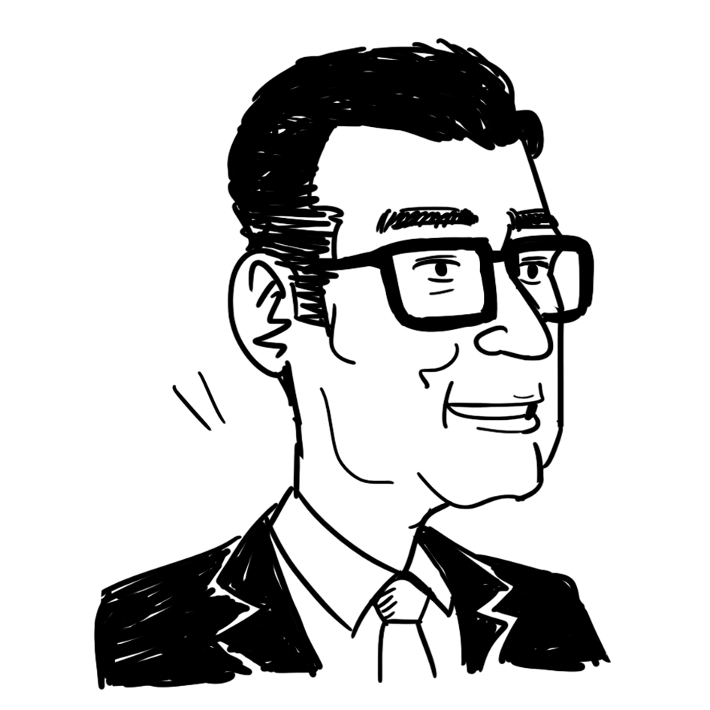  A commentator | Even if the power companies raise electricity charges, the cost of living for the general public will not significantly increase. The low-carbon transition will have a minimal impact on citizens.
  An environmentalist | During the low-carbon transition, power companies are trying to make energy systems more efficient and reduce the use of non-renewable fuels for power generation. Investing in clean energy infrastructure also helps establish new industries.

(a) Refer to Source A. Explain which market structure Hong Kong’s electric power industry belongs to.
(2 marks)

(b) Refer to Source B. Explain whether the amount of the electricity charges relief would be included in the calculation of Hong Kong’s gross domestic product. (2 marks)

(c) Refer to Source C. Justify the statement of the commentator in Source D. (2 marks)

(d) Refer to Source D. Explain how the suggestion made by the citizen in Source D will affect the price of solar power systems. (2 marks)

For part (e), candidates are required to present their answer in essay form. Criteria for marking will include use of sources and economic theories, relevant content, logical presentation and clarity of expression.

(e) Suppose the government has the following two proposals to promote low-carbon development:

Proposal I: to increase the electricity charges relief provided to eligible residential electricity accounts in order to support power companies in continuing their low-carbon transition
Proposal II: to provide tax incentives for households that install renewable energy systems and generate electricity using them

With reference to the above sources and your own knowledge in Economics, discuss the effects of EACH proposal on Hong Kong, including:

- income distribution,
- aggregate output, and
- government revenue and/or expenditure
(14 marks)

Please stick the barcode label here.

END OF SECTION B | END OF SECTION B

Please stick the barcode label here.
0
Quantity
Unit price
MC
D = MB
Figure 2
Section C (16 marks) Answer any ONE question.

12. DingDingExpress is the only tram service provider in Country A. Figure 2 shows its demand curve and marginal cost curve. DingDingExpress adopts simple monopoly pricing.

(a) Indicate the profit-maximising output (Q_{M}) and price (P_{M}) in Figure 2. Explain whether DingDingExpress adopting simple monopoly pricing is efficient. (5 marks)

(b) Suppose the government provides a subsidy to DingDingExpress, which is a fixed amount regardless of the quantity produced.

(i) Indicate the profit-maximising output (Q_{S}) and price (P_{S}) after the provision of the subsidy in
Figure 2. (2 marks)

(ii) Explain whether economic efficiency would be affected as a result of the subsidy. (2 marks)

(c) DingDingExpress offers an ‘early bird discount’. Passengers who take the tram before 8 a.m. can enjoy a 30% discount on the fare. Explain whether this arrangement constitutes price discrimination. (3 marks)

(d) Suppose the government grants a few licenses for other tram service providers. However, DingDingExpress refuses to supply its railway facilities to them, and those facilities are essential for providing tram services.

(i) Name the anti-competitive behaviour that DingDingExpress may constitute. List ONE possible motive for DingDingExpress. (2 marks)

(ii) State TWO ways the above behaviour may harm consumers. (2 marks)

Please stick the barcode label here.

Figure 3

P_{A}
Good Y (units)
A
T
Good X (units)
0
A’
T’
13. Figure 3 shows the production possibility frontier AA’ of Country A. P_{A} is the production point when there is no trade.

(a) Explain why the production possibility frontier of Country A is concave to the origin. (1 mark)

(b) Initially Country A did not engage in international trade. Indicate the consumption point of Country A as CA in Figure 3. Explain your answer. (2 marks)

(c) TT’ is the international price line of good X. Explain whether Country A would have a comparative advantage in producing good X. (3 marks)

(d) Country A decides to open up to international trade.

(i) Country A consumes fewer good X and more good Y after trade. In Figure 3, indicate the production point of Country A after trade as P_{T} and its consumption point as C_{T}. Explain why Country A is better off after trade. (3 marks)

(ii) Indicate the volume of exports in Figure 3. (1 mark)

(e) Suppose there is a technological enhancement in Country A which doubles its productivity on good X and good Y. Explain whether your answer in (c) will change. (2 marks)

(f) Country A has achieved a higher Human Development Index after opening up to trade. Give TWO possible reasons to explain this phenomenon. (4 marks)

Please stick the barcode label here.

END OF PAPER

Please stick the barcode label here.

